# Paper/Part Three – “Watershed and oceanic controls on seasonal and temporal patterns in sediment deposition on a fringing reef flat embayment”

## Introduction

The complex spatial and temporal interaction of terrigenous sediment inputs, sediment resuspension, and circulation can significantly alter the quantity, composition, and residence time of sediment in coral reefs, causing subsequent impacts on coral ecology (Storlazzi et al., 2009). Depending on the interacting hydrodynamic processes on the reef, increased terrigenous sediment supply to an embayment can increase sediment deposition on corals (Draut et al., 2009), or have no effect (Hoitink and Hoekstra, 2003). Coral stress and mortality resulting from sediment in the water column and sediment deposition is a complex process depending on hydrodynamics, sediment biogeochemistry, coral morphology, and coral physiology (Fabricius, 2005; Weber et al., 2012), making it difficult to quantify coral stress caused by sediment using biological monitoring strategies alone. This research focuses on understanding how the temporal and spatial distribution of sediment deposition on the reef is controlled by terrigenous sediment loading and oceanic conditions. Future research can relate the measured sediment deposition to coral health. Given the increase in sediment discharge to coastal waters caused by anthropogenic watershed disturbance on tropical islands, understanding how the interaction of flood-supplied terrigenous sediment and water circulation controls sediment deposition and residence time is essential for identifying and mitigating coral health impacts (Draut et al., 2009).

**Hydrodynamic controls on sediment deposition and residence time**

Hydrodynamic circulation driven by tides, wind, and waves can deflect plumes of suspended sediment away from coral, limiting stress from light attenuation due to turbidity (Hoitink and Hoekstra, 2003; Muzuka et al., 2010), and/or advecting suspended sediment over the coral and out to sea before it is deposited. Wave energy, either from remotely generated surface gravity waves or local wind-driven waves, is typically limited on shallow reef flats, but can cause high orbital velocities that shorten sediment residence time by resuspending and flushing previously deposited sediment or preventing sediment deposition (residence time = 0 min). Ogston et al. (2004) showed that while wave orbital velocities alone are generally unable to exceed the critical shear stresses necessary for sediment resuspension on fringing reef flats, in combination with the relatively strong current velocities, they can resuspend or prevent deposition of fine-grained sediment.

**Phasing of sediment input and hydrodynamic conditions**

Sediment loading from the main Faga’alu stream to Faga’alu bay is an important control on sedimentation rates on corals, but wave conditions decrease sediment deposition in two ways: 1) by flushing recently loaded sediment away from the corals before it can be deposited (in-phase with sediment discharge) and 2) resuspending and removing sediment that has been previously deposited (out-of-phase with sediment loading). Sediment loading out-of-phase with high swell conditions causes higher deposition rates and longer residence times than sediment loading in-phase with high swell conditions (Draut et al., 2009; Storlazzi et al., 2009).

In contrast to many small, mountainous watersheds in temperate coastal regions where fluvial discharge and wave energy commonly coincide (Warrick et al., 2004), discharge, deposition, and reworking of flood sediment is often decoupled on tropical islands, causing high deposition rates and residence times of terrestrial sediment (Draut et al., 2009; Storlazzi et al., 2009). Conversely, seasonal wind and wave patterns can be coupled with sediment discharge or resuspension to decrease sediment deposition and residence times (Hoitink and Hoekstra, 2003; Muzuka et al., 2010). Some studies correlate long term sediment accumulation with increased sediment supply, and by extension decreased coral health (Ryan et al., 2008), but there is strong evidence of hydrodynamics often preventing deposition or significantly controlling resuspension, and resuspension causing significant coral stress (Ogston et al., 2004).

**Measuring sediment accumulation on the reef**

Many researchers and environmental managers are interested in determining the location and severity of terrigenous sediment impacts on coral health, but developing an ecologically meaningful measure of sediment impact has proven difficult. Much research has focused on correlating coral health metrics like percent coral cover with sediment metrics like turbidity in the water column (Fabricius et al., 2012) or sediment accumulation on the reef or in traps (measured as mass per area per time)(Muzuka et al., 2010; Presto et al., 2006). Deploying tube traps is the most common method for measuring sediment accumulation in shallow coral reef environments, and collected sediment can be analyzed for composition to determine the terrigenous fraction (Gardner, 1980; Storlazzi et al., 2011; Takesue et al., 2009; White, 1990). Despite methodological differences in the collection and interpretation of these data (Storlazzi et al., 2011), it is difficult to determine if these are ecologically meaningful indicators of coral stress. Indeed some corals are well-adapted to turbid conditions (Perry et al., 2012), and deposited sediment can be removed actively by the coral itself, or passively by wave action, before it is lethal. The stress on the coral organism increases linearly with the deposition amount and the duration of exposure (Fabricius, 2005) but tube traps do not allow for sediment resuspension, making it impossible to evaluate the residence time of deposited sediment (Storlazzi et al., 2011). Field et al. (2012) proposed the use of “SedPods” where sediment accumulation is measured on a flat surface, allowing resuspension, but sediment tube traps are still widely used. Tube traps have been used to determine critical thresholds for coral stress, and although these thresholds vary by coral species and environmental setting, they give a relative measure of coral stress and can be compared among sites. While the complex interaction of sediment composition, hydrodynamics, and coral physiology are important, basic questions about location and controls on net terrigenous sedimentation rates are unknown at the study site in American Samoa, and are the focus of this research.

**Intellectual merit**

Many studies have measured sediment deposition on corals but few have developed an integrated understanding of the temporal interaction of flood-supplied sediment, water circulation patterns, and the resulting deposition on corals. The few studies that have integrated terrestrial and marine sediment dynamics were limited by a small number of flood events due to limited number of flood events in drier areas (Draut et al., 2009; Ogston et al., 2004; Storlazzi et al., 2009) or limited deployment times (Wolanski et al., 2005, 2003). Other studies have focused on only the tropical wet season when deposition is highest, and neglected investigating the important dynamics of potential sediment removal and flushing during the dry season (Muzuka et al., 2010; Victor et al., 2006).

The study will have important management applications, since detection of the efficacy of various efforts to mitigate sediment supply may be complicated by variable hydrodynamic conditions. This study will provide a framework for controlling for hydrodynamic effects that will allow quantification of the impacts of ongoing sediment mitigation efforts.

**Modeling monthly mean sedimentation**

Interpretation of any change in sediment accumulation rates following mitigation activities requires a conceptual and mathematical model of the dominant circulation conditions that control sedimentation on the reef. The modeling approach is similar to other efforts that have attempted to limit the complexity of the modeling approach, but still account for the impact of ocean conditions on sedimentation (Fabricius et al. 2012). The proposed model is a semi-empirical model using linear regressions and statistical methods to address the following research questions and test hypotheses about the influence of the dominant controls on sediment accumulation.

## Research Questions

The research questions for this paper are:

1. Temporal controls:
   1. How do flood-supplied terrigenous sediment and hydrodynamic conditions interact to control the gross and net rate of terrigenous sediment deposition at monthly time scales at different locations in a coral reef embayment?
   2. Is there a seasonal pattern of sediment deposition and removal, with sediment being deposited during the wet season when storms coincide with quiescent ocean conditions and removed during the dry season when storms coincide with active ocean conditions?
2. Spatial controls:

What controls the spatial distribution of sediment deposition, and can it be predicted by the flow direction and velocity of water over the reef?

**Conceptual model and hypothesized interactions of watershed and hydrodynamic processes**

This research proposes to model monthly sediment accumulation as a function of watershed inputs and hydrodynamic conditions to test hypotheses about their temporal and spatial distributions:

Temporal: In the study location (American Samoa), the wet season (Nov-Apr) is associated with large sediment loads from the watershed, light or absent trade winds and relatively low wave heights, while the dry season (April-Oct) has lower sediment loading, stronger trade winds and larger swell heights. Several studies have found weak or no correlation between sediment trap collection and rainfall parameters (Bothner et al., 2006; Victor et al., 2006) but it is well-known that sediment yield from small, mountainous watersheds can be poorly correlated with precipitation (Duvert et al., 2012). By correlating sediment trap collection with measured and modeled sediment yield from the watershed, this research hopes to assess the influence of variable sediment loading on sediment accumulation.

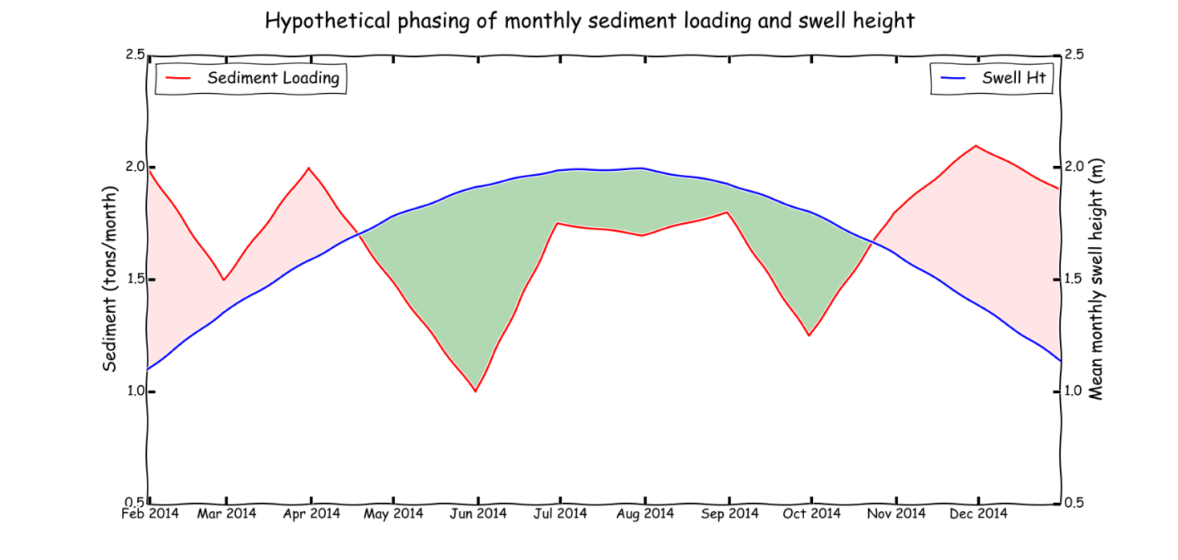

Figure 1. Hypothetical phasing of monthly sediment loading from the watershed and offshore swell height(Draut et al., 2009). Red shaded areas indicate a time of net terrigenous sediment deposition and green shaded areas indicate a time of net terrigenous sediment removal and suspension of marine-derived sediment.

Hypothesis 3.1: Terrigenous sediment deposition will be highest and marine-derived deposition lowest in the wet season, when rainfall events and watershed sediment inputs co-occur with light offshore winds and quiescent ocean conditions. In the dry season, stronger, onshore trade winds and higher average swell heights will decrease rates of terrigenous sediment deposition and shorten residence times, but will increase resuspension and deposition of marine-derived carbonate sediment compared to the wet season.

Hypothesis 3.2: The spatial distribution of sediment deposition will be controlled by the velocity of water circulation over the reef flat, and the distance from the point of sediment discharge (stream mouth). At the study site, current measurements and field observations suggest that there is a consistent hydrodynamic pattern, where ocean water is pumped over the southern reef crest by breaking waves, driving clockwise flow over the reef (Figure 2) that protects the southern reef from the sediment plume, and deflects the sediment plume over the northern reef.

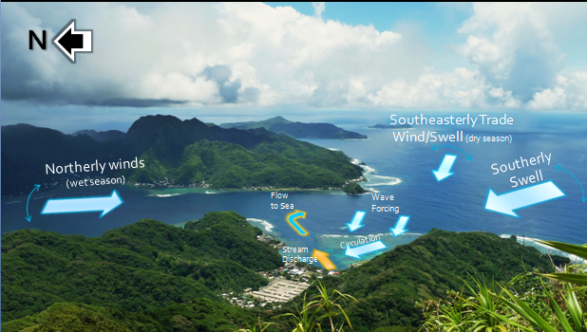

Figure 2. Conceptual model of wave/wind forcing of the dominant circulation pattern of sediment-poor ocean water deflecting sediment-rich stream discharge to the northern reef.

Hypothesis 3.3. The relative importance of watershed and hydrodynamic controls on the temporal variability will differ by location in the bay, with more hydrodynamic control at the ocean-ward parts of the reef that are not exposed to watershed inputs, and greater importance of watershed inputs in the parts of the reef where terrigenous sediment is hypothesized to accumulate.

These hypotheses will be tested with measurements of sediment loading from the watershed, of accumulation and composition of sediment in traps on the reef, and of oceanic and meteorological conditions. The impact of watershed inputs and water circulation will be assessed with statistically-based mathematical models.

## Pilot Study

In February and March, 2012, I measured total sediment accumulation at nine locations on Faga’alu reef using simple tube traps (STT), a ceramic tile (TILE), and an Astroturf mat (MAT). From April 2013 through June 2013 I measured total sediment accumulation using SedPods (Field et al., 2012). Sediment accumulation varied according to sediment trap type, location, and ocean conditions, and included both reef-derived carbonate and terrigenous sediment (Figure 2 and 3). No assessment of sediment composition was made, but sediment accumulation rate appeared to be controlled by sediment input from Faga’alu stream, and hydrodynamic circulation caused by high wave events.

The pilot study also demonstrated strong spatial variability in sediment deposition rates, with high rates near the stream mouth and on the northern reef, consistent with hypothesis 3.2. The pilot study data are insufficient to test the hypotheses due to a limited number of samples (n=5), no assessment of sediment composition, and insufficient data on hydrodynamic conditions. The methods developed in the pilot study have informed the development of the methods for the proposal.

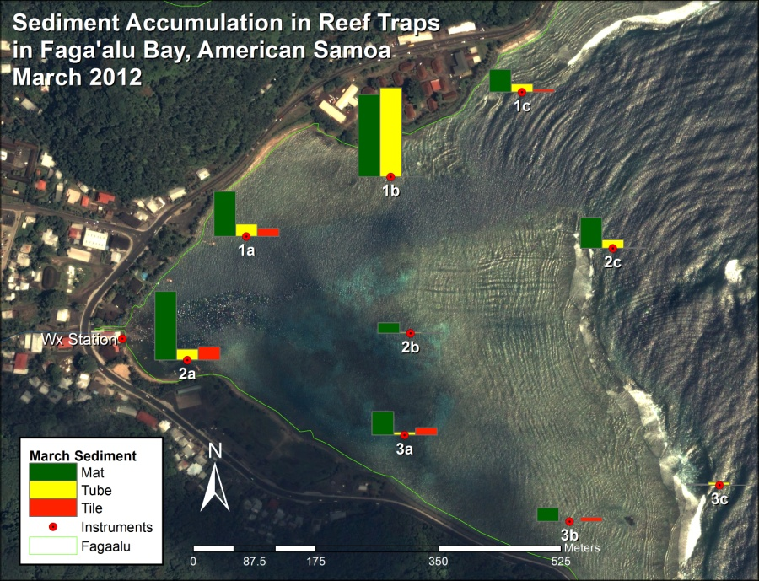

Figure 3 Gross sediment accumulation in tube, tile, and Astroturf sediment traps

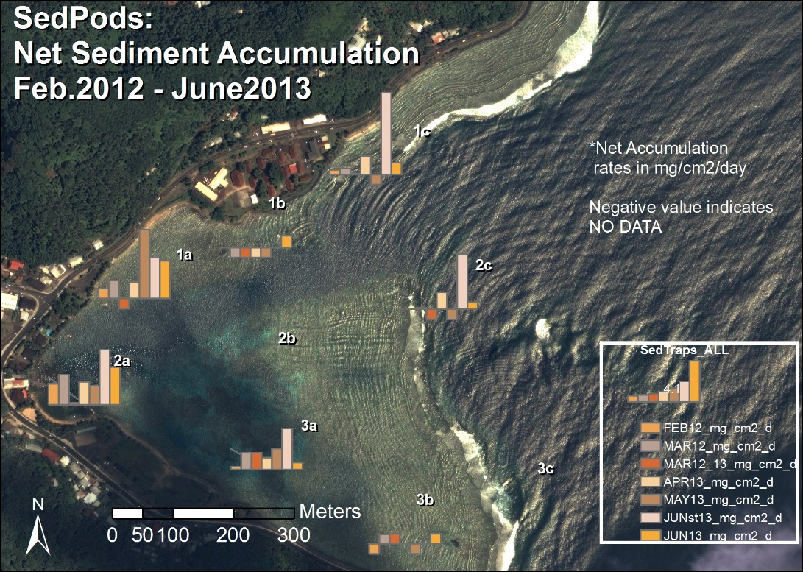

Figure 4 Net sedimentation on SedPods in Faga'alu Bay. Ceramic tiles were used in 2012 and were assumed to be comparable to SedPods.

## Methods

### Measuring sediment accumulation on the reef

Approaches to measuring sediment impacts on coral health have included monitoring suspended sediment concentration or turbidity in the water column (Wolanski et al., 2003) but suspended sediment in the water column can be caused by resuspension of nearby sediment due to shear stresses induced by wave- orbital velocities and/or mean currents, advection from another area, or any combination of these processes, and does not necessarily lead to sediment deposition. Geochemical methods (Takesue et al., 2009), sometimes in conjunction with coral skeleton analysis (Grove et al., 2010; Perry et al., 2012), have been used to infer sediment deposition over decadal and century time scales (Ryan et al., 2008) but can be complicated by subsequent sediment reworking and these time scales are ill-suited to the time scales of coral mortality and effective environmental management. Sediment traps are the most common method for measuring sediment accumulation in shallow coral reef environments, and collected sediment can be analyzed for composition to determine the terrigenous fraction (Storlazzi et al., 2011; Takesue et al., 2009; White, 1990).

Tube traps collect sediment over the deployment period, typically 1-90 days (Storlazzi et al., 2009; Victor et al., 2006; Wolanski et al., 2005), yielding an integrated sample and average collection rate in mass per area per time, but Field et al. (2012) argue the collection rate is a gross collection rate since particles cannot be removed as they would be on natural benthic surfaces. Since tube traps slow the water column and prevent resuspension, they can effectively trap sediment that would have been advected through the area without being deposited (Storlazzi et al., 2011). To more accurately quantify “net” sedimentation, Field et al. (2012) proposed the use of “SedPods” where a flat, circular, roughened concrete surface is deployed which allows for resuspension, similar to the surrounding benthic substrate. Deploying a tube trap in conjunction with a SedPod provides a comparison of gross and net sediment accumulation, and an assessment of the interaction of sediment loading and removal at time scales relevant to coral mortality and management.

SedPods (Field et al., 2012) and tube traps (Storlazzi et al., 2011) have been deployed at nine locations on the reef flat (water depth 1-2 m) and reef crest (10-15 m) in Faga’alu Bay, are being collected monthly to provide data on monthly sediment accumulation rates (mg/cm2/d) (Figure 2) from February 2014 through January 2015. Collection will be performed by Messina when in the field and by Department of Marine and Wildlife Resources when Messina is not on-island. See QAPP 2.2.11.1-2.2.11.4.

### Sediment composition and particle size

Sediment samples collected in tubes and SedPods are wet sieved to separate the sand and fine fractions for analysis and rinse salt from the sample. The samples are dried and weighed to determine bulk sediment accumulation before being shipped to SDSU to characterize the geochemical composition (percent terrigenous, carbonate and organic) using Loss on Ignition (LOI) method (Heiri et al., 2001; Santisteban et al., 2004). The LOI method uses a muffler furnace that can sustain 950 C for several hours to combust and remove organic, then carbonate material, leaving only terrigenous residue. All carbonate sediment is assumed to be reef derived, all non-carbonate is assumed to be terrigenous (Ryan et al., 2008). See QAPP 3.5. The particle size distribution and geochemical composition of sediment collected in traps may differ from sediment that accumulates on the reef, so sediments in the immediate area of the trap will also be sampled. See QAPP 2.2.11.5.

### Modeling temporal variation in sediment accumulation

Statistical models, including both simple linear regression models and more complex generalized additive mixed models (GAMMs) will be used to establish the relative controls of each measured variable on sediment accumulation rates, both the average for North and South reefs, and at each of the nine locations where accumulation will be measured.

A semi-empirical model of sediment accumulation (Si) at location *i* in the bay during month *t* as:

|  |  |  |
| --- | --- | --- |
|  |  | Equation 1 |

where *Sw(t)* is sediment loading from the watershed in month *t*, *Ri(t)* is mean water residence time over the reef flat at location *i*, either the mean of the month or mean during storm events, and *SBi*is substrate type (live coral, dead coral, coralline sand, mud) at location *i*, which is a proxy for sediment availability in the microenvironment around the sampling location.

**Sediment Loading**

Field observations suggest that sediment larger than fine sand settle before reaching the corals, so sediment accumulation and loading refers to particle sizes less than 16um (fine sand). Monthly sediment loading from the watershed (Sw) is calculated as the sum of suspended sediment yield from storm events (SSYi), using the model from paper 1:

|  |  |  |
| --- | --- | --- |
|  |  | Equation 1 |
| where SMONTH is the sum of SSYEV for n events in the month. | | |
|  |  | Equation 2 |
| where the regression coefficients α and β are obtained by ordinary least squares regression on the logarithms of *SSYi* and *Qmax* (paper 1). Suspended sediment from each event during the month is summed: | | |

**Hydrodynamics**

Water residence time for each 100m x 100m grid cell containing a sediment trap/SedPod will be calculated from NOAA WaveWatch III swell model output and the model developed in Paper Two. Residence time is the amount of time a parcel of water remains in the grid cell, and is directly calculated from flow speed. Paper 2 proposes that residence time decreases with increased mean monthly swell height, and the relationship between swell height and flow speed in each grid cell will be determined in Paper Two, of the form:

|  |  |  |
| --- | --- | --- |
|  |  | Equation 3 |
| where *R(t)* is the water residence time for month *t*, is mean monthly swell height, and *a* and *b* are calibration coefficients. Depending on the modeling results from Paper Two, it may be necessary to calculate and average water residence time daily to determine mean monthly residence time. | | |

**Monthly mean versus daily models**

Monthly sediment accumulation may be a function of sediment loading and water circulation processes interacting on daily time scales, where hydrodynamic conditions only on the day of sediment discharge and not the mean monthly condition, are important. If monthly sediment loading and monthly mean residence time do not adequately predict sediment accumulation in the sediment traps, it might be necessary to investigate sediment loading and water residence times on daily scales, and further refine the statistical analysis and equations. In that instance, daily sediment loading and daily mean residence time will be used to assess daily deposition, which can be compared to the monthly sediment accumulation measurements.

**Monthly and Seasonal patterns of sediment deposition and removal**

Two time scales of analysis will be pursued: monthly and seasonal (dry and wet season). Monthly measurements of sediment loading, hydrodynamic conditions, and the subsequent sediment accumulation are used to assess the importance of controls on net sedimentation. A monthly time interval was chosen to correspond with other studies found in the literature (Muzuka et al., 2010; Victor et al., 2006), to sample enough storm events to collect enough sediment for analysis, and for logistical reasons due to the high spatial coverage of sites and limited field personnel and resources.

An assessment of differences between dry and wet season sediment dynamics is useful to determine if there are seasonal patterns or modes that may be relevant to long term sediment accumulation (Ryan et al., 2008) or coral conservation and restoration (Muzuka et al., 2010). Previous studies have focused on wet season sediment deposition (Muzuka et al., 2010; Victor et al., 2006) and may overestimate long term sediment accumulation. It is hypothesized (hypotheses 3.1) that net deposition predominantly characterizes the wet season, and a net sediment removal, or limited deposition, predominantly characterizes in the dry season. The sediment accumulation data will be grouped by season and averaged to determine if there are seasonal patterns of net deposition/removal.

### Modeling spatial variation of sediment accumulation (kernel values)

An important consideration for coral conservation is determining the spatial distribution of sediment impacts from terrigenous sediment loading. Current conservation models typically use the distance from the river mouth or other point source to assess pollution risk to coral reefs (Klein et al., 2012), but wave and wind-driven flow over the reef can deflect suspended sediment away from corals (Hoitink and Hoekstra, 2003) or focus impacts on small areas of reef (Presto et al., 2006). To explain the spatial variation of sediment accumulation between sediment traps, and determine if flow direction or distance from the stream is more important, a kernel-based approach will be used. The “kernel” is a method of analyzing spatial distribution by normalizing all measurements by the maximum observed measurement, which are then modeled as a function of water flow direction (towards/away the stream mouth) and distance from the stream mouth:

|  |  |  |
| --- | --- | --- |
|  |  | Equation 4 |
| Where is the mean monthly sediment accumulation measured at trap *i*, SedAccMax is the highest observed sediment accumulation of all sediment traps, *Vϴi* is velocity in the direction away from the stream mouth at location *i,* and *di* is distance from the stream mouth at location i. | | |

## Expected Results/Outcomes

A serious problem faced by attempts by environmental managers and researchers to assess stress on reefs is the fact that there are few, if any, reefs with adequate baseline data (Risk, 2014). The proposed work will characterize and quantify the amount, composition, and particle sizes of sediment contributing to coral reef degradation in Faga’alu, informing mitigation strategies to reduce terrestrial sediment loading to the priority coral reef. The work will establish a baseline to measure the performance of future mitigation projects by developing a model that relates sediment loading from the watershed to sedimentation rates on the reef under varying oceanographic conditions.

The main outputs of the work will consist of a statistical model of sedimentation in Faga'alu Bay that quantifies the relative importance of watershed inputs and ocean circulation on sediment dynamics, and tests the above hypotheses.